# Lab #6, #7 & #8

**Objective:** Generate reports using both MDX and Excel Pivot table for the following scenarios:

* Display the standard cost of all the products along with their categories according to the regions in which they were sold. Which region is the most and the least expensive according to the result retrieved?

**Answer:** According to the results retrieved, the most expensive region is United States and the least expensive region is Canada.

**Excel Pivot Table:**

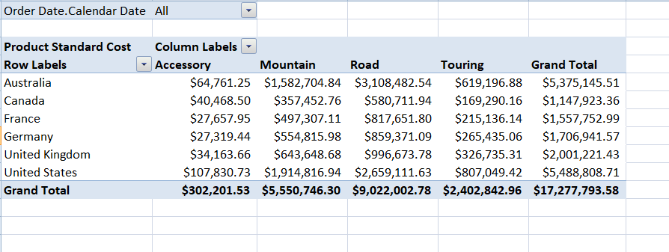

**MDX:**

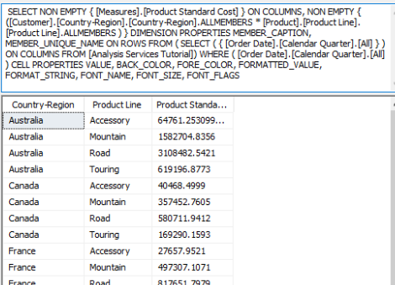

* Display the Tax amount for customers according to their educations and occupations over calendar year. Do these factors impact the tax amount paid by a customer? Which class of customers pays the highest tax amount?

**Answer:** Customers from the professional class pay the highest amount of tax.

**Excel Pivot table:**

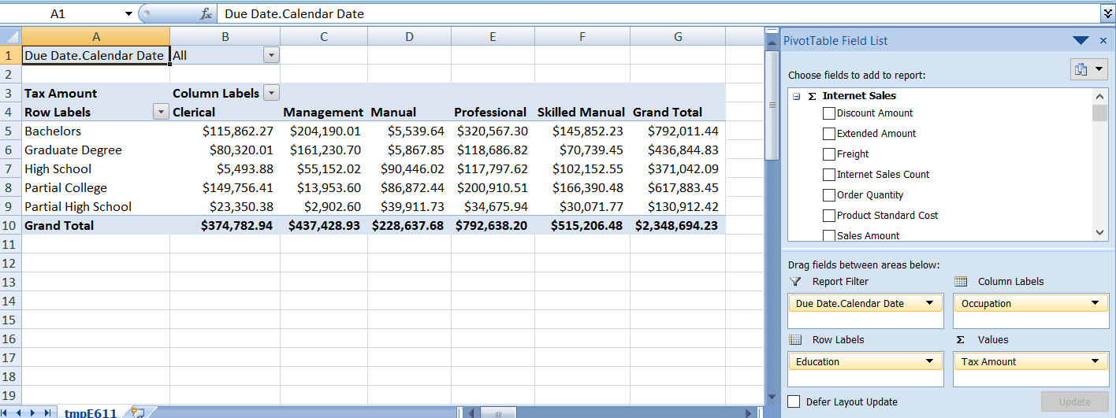

**MDX:**

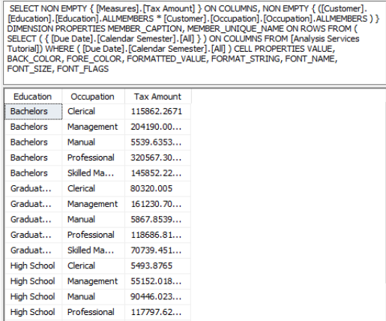

* Display the sales amount for all products (use product hierarchy) purchased according to the calendar year and filter the results according to the customers’ genders. What type of customers bought the most Biking products?

**Answer:** According to the results retrieved, male customers in the married category and female customers in the single category have bought the most biking products.

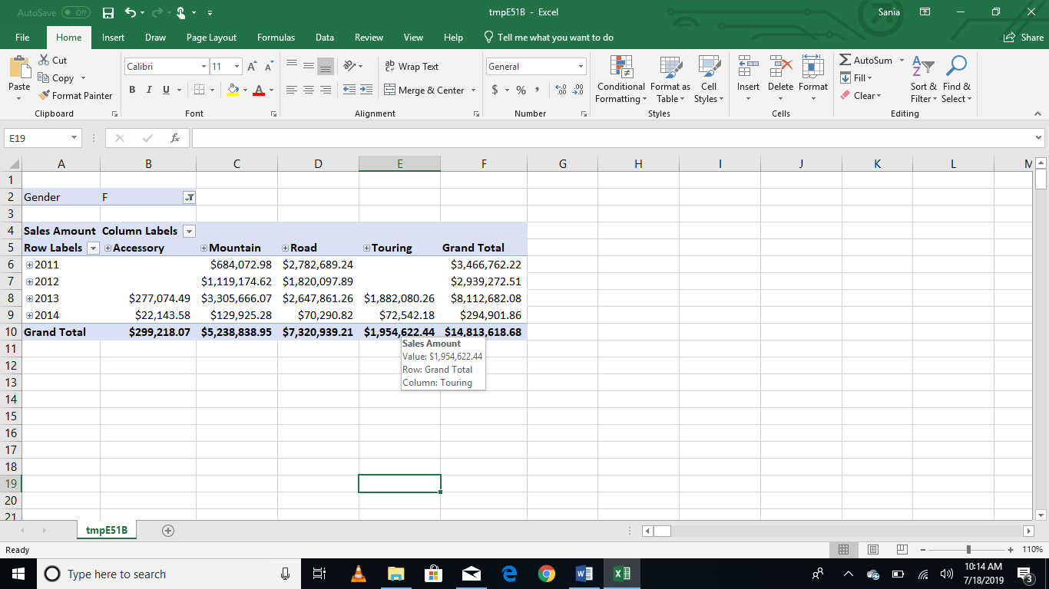

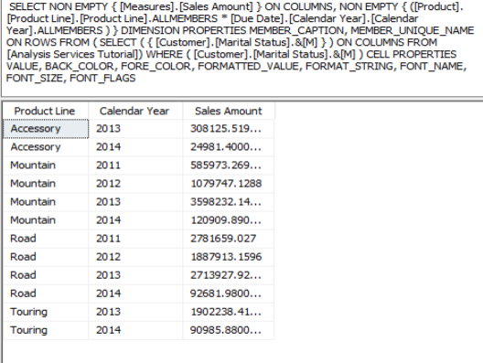

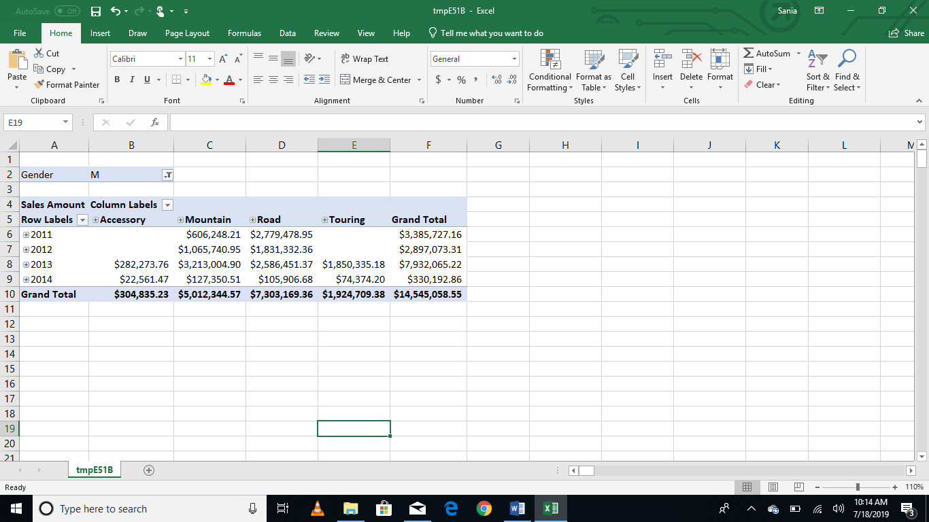

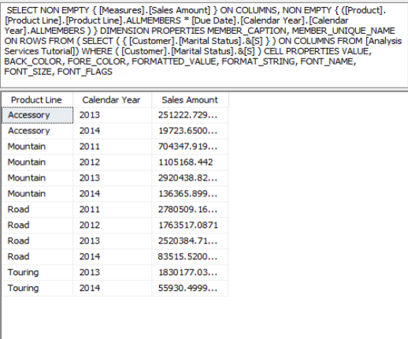

* Display the total days required to manufacture the products (use product hierarchy) according to region and time (use date hierarchy).

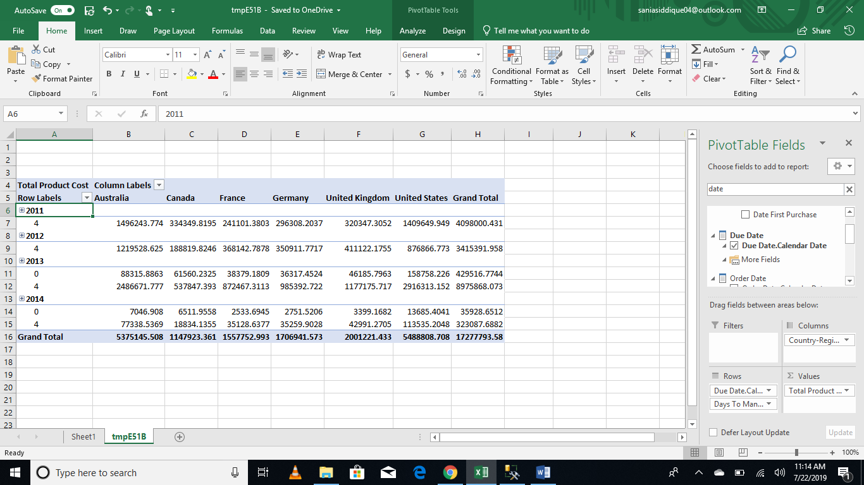

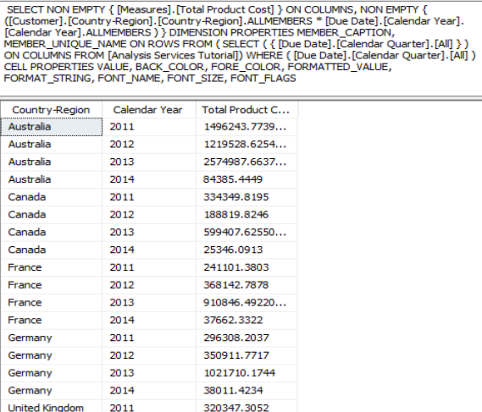

* Display the order quantity for all the products ordered by customers according to their marital statuses and genders. Filter the results for customers having yearly income greater than or equal to 50,000.

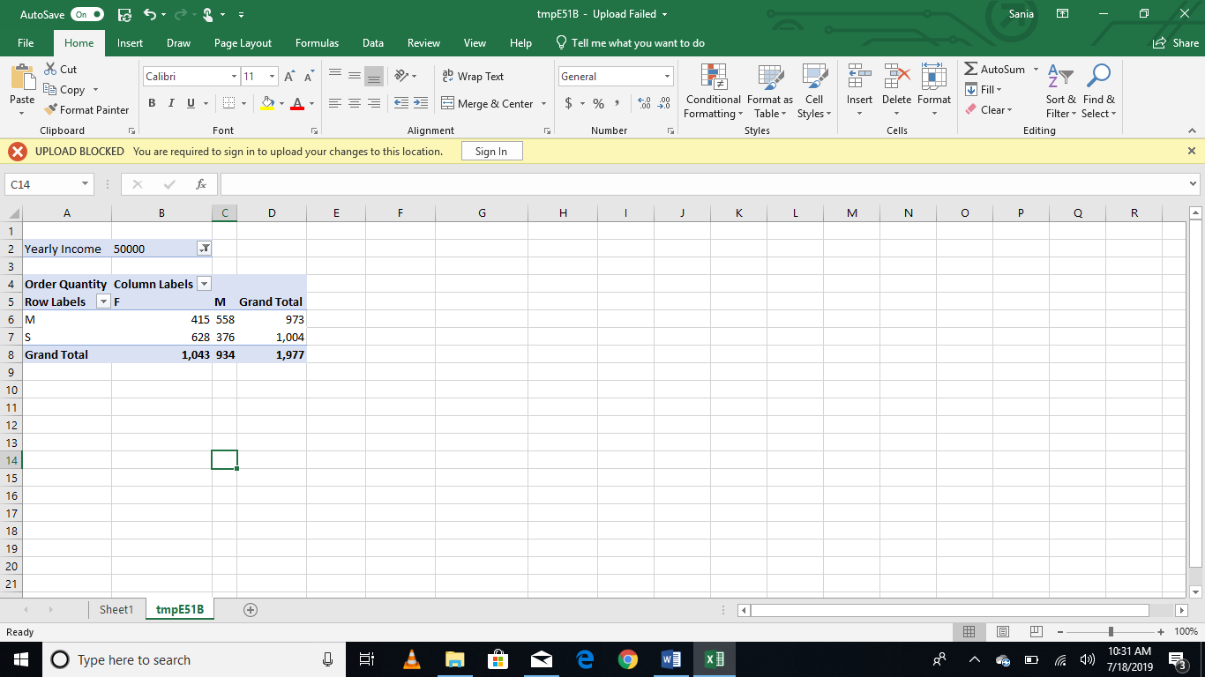

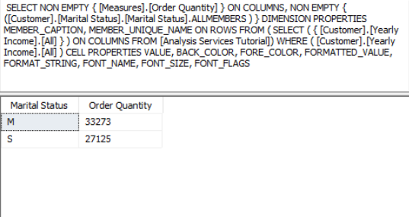

Generate pivot charts for any 3 scenarios mentioned above to better visualize the data.

